Selecting an OpenAI-Compatible
Open-Source or Source-Available Chat Client
A Comparative Engineering Assessment of Eight Leading Projects
Nathan Conklin
nathan.conklin@vt.edu
Department of Computer Science,
Virginia Tech
3 August 2026

Abstract
This report compares eight chat clients and adjacent AI platforms that can connect to OpenAI models through the OpenAI API or an OpenAI-compatible interface. The assessment reflects official project materials available on 3 August 2026. Six projects use standard open-source licenses; Open WebUI and LobeHub use project-specific source-available licenses. The comparison covers programming language, architecture, user-interface capabilities, deployment model, licensing, measured source scale, and assessed front-end and back-end modification difficulty. Source scale reports non-blank source lines counted from default-branch clones taken on 3 August 2026 under the exclusions stated in Scope and Method; the rankings are an engineering assessment under the stated criteria rather than an industry benchmark. Under those criteria, Open WebUI received the highest capability rating, LibreChat received the highest rating among permissively licensed full platforms, NextChat received the lowest assessed modification difficulty, and Hugging Face Chat UI provided the strongest balance of production features and modifiability. Current LobeHub is broader than a chat client and is included because it evolved from LobeChat.

Executive Recommendation
The preferred choice depends on how much of the existing product should remain. Under this report's criteria, Open WebUI received the highest general-platform capability rating because it combines a polished interface with multi-user controls, RAG, tools, MCP, agents, and a Python backend. LibreChat is the stronger permissively licensed choice when broad multi-provider support and a mature agent and artifact environment are primary requirements. Both projects are large; neither is an efficient starting point when most of the interaction design will be replaced.
For a research interface centered on visualized reasoning, decision graphs, evidence panels, confidence displays, and operator intervention, NextChat received the lowest assessed modification difficulty. Its narrower product model and familiar Next.js structure reduce the amount of unrelated platform code that must be preserved. NextChat has not tagged a release since v2.16.1 in July 2025, and its 2026 commits add unit tests rather than provider or model support, so a team that selects it should plan to maintain the fork without upstream releases. Hugging Face Chat UI is the stronger middle option when the prototype still needs authentication, history, files, routing, and MCP. Open WebUI becomes the preferred foundation when the research interface must operate inside a larger multi-user AI platform. These recommendations should be confirmed through a task-specific proof of concept before a production commitment.
LobeHub requires separate treatment. The current project positions itself as a Chief Agent Operator that hires, schedules, coordinates, and reports on teams of agents operating continuously. It still includes chat and assistant capabilities, but it is no longer directly comparable to a focused chat client. Its community license permits certain commercial use of unmodified software but requires a commercial license to develop and distribute derivative work. It should therefore be evaluated as an agent-operations platform, or the analysis should be pinned to a specific historical LobeChat release.

Scope and Method
The assessment was validated against the official repositories, README files, release materials, and license files for the eight projects [1], [2], [3], [4], [5], [6], [7], [9]. Open-source classification follows the Open Source Initiative's requirement that licenses allow modification and redistribution of derived works [8]. Feature breadth and architecture were evaluated from documented capabilities, repository structure, deployment model, and the number of subsystems that a modification would cross. The review reflects the projects as they appeared on 3 August 2026; repositories were not pinned to commit identifiers, so fast-moving claims should be refreshed before procurement or implementation.
Front-end difficulty reflects component count, design-system coupling, client state, responsive behavior, and desktop packaging. Back-end difficulty reflects service count, persistence, authentication, provider routing, RAG and agent subsystems, automation, and native integration. The overall ranking combines those factors with the expected effort required to understand the repository before making a structural change. Source scale reports non-blank lines in source files, counted from shallow clones of each default branch taken on 3 August 2026. The count covers TypeScript, JavaScript, Svelte, Python, Rust, Swift, and stylesheet files, and excludes dependencies, build output, generated files, lockfiles, translation catalogs, vendored code, and documentation. The reported figure also excludes tests; including them raises LibreChat to roughly 759k lines and LobeHub to roughly 1,591k. Counts shift with counting rules, so a procurement decision should re-run the count against pinned commits.

Validation Limits and Reproducibility
The capability and modification rankings are this report's engineering judgments, not maintainer claims or published industry consensus. Source scale is measured, but the rankings built on it have not been validated through timed implementation trials. A final selection should test representative tasks such as changing navigation, adding a message visualization, persisting a new metadata field, adding an OpenAI-compatible endpoint or MCP tool, and deploying the modified application. The evaluation should record packages touched, languages involved, database or API contracts affected, automated-test coverage, build time, and developer effort. License summaries are technical procurement notes rather than legal advice.

Key Findings at a Glance
- Highest capability rating: Open WebUI received the broadest integrated-platform rating under this report's criteria, including administration, RAG, tools, MCP, and a Python backend.
- Highest-rated permissive full platform: LibreChat combines broad provider support and agent capabilities with an MIT license, although it received the highest overall modification-difficulty score.
- Lowest assessed redesign difficulty: NextChat remains the narrowest foundation for reshaping the interaction design at roughly 30k measured source lines, subject to proof-of-concept validation and to the slow release cadence noted below.
- Strongest assessed balance: Hugging Face Chat UI preserves useful production features at roughly 33k measured source lines, the second smallest codebase in the comparison, while maintaining a focused OpenAI-compatible API boundary.
- Specialized fits: AnythingLLM is oriented toward document, RAG, memory, and scheduled-agent workflows; Jan is oriented toward native local-first use.
- Scope and license qualification: Current LobeHub is an agent-operations platform rather than a direct chat-client analogue, and both LobeHub and Open WebUI require review of project-specific source-available license terms.

Master Comparison Table
Table 1 compiles the major decision data for all eight projects. Capability and difficulty ranks are assessment results rather than industry benchmarks. A difficulty rank of 1 means the most difficult codebase to modify; 8 means the least difficult. Source scale reports measured non-blank source lines excluding tests, counted as described in Scope and Method. The asterisk on LobeHub indicates that its current agent-operations scope is broader than a conventional chat client, which limits direct comparison.
Tool / project | License | Stack / form | API support | UI capabilities | Measured  source scale | Front end | Back end | Difficulty rank  (1 hardest) | Best fit / caveat
Open WebUI  Capability rank: 1  Project repository | Open WebUI License; source-available. Branding generally must remain unless the deployment has 50 or fewer end users in any rolling 30-day period, written permission is obtained, or an enterprise license applies. | Python/FastAPI backend; TypeScript/SvelteKit frontend; Self-hosted web platform; Docker; multi-user | Native OpenAI-compatible API support; also Ollama and other compatible providers | Chat history, model picker, files and RAG, Notes, voice and image workflows, tools, MCP, agents, RBAC, admin controls, plugins | 221k  (measured) | Hard (rank 4) | Hard (rank 5) | 4 of 8 | Highest capability rating in this assessment; suited to multi-user administration, RAG, tools, and Python. Caveat: broad feature surface and project-specific branding terms.
LibreChat  Capability rank: 2  Project repository | MIT | TypeScript/React frontend; Node.js API; MongoDB; shared monorepo packages; Self-hosted web platform; Docker; multi-user | OpenAI, Azure OpenAI, Anthropic, Bedrock, Google, custom endpoints, and OpenAI-compatible services | Multi-provider chat, agents and subagents, MCP, artifacts, code execution through a separate sandbox service, custom actions, web search, files, model switching, enterprise authentication | 379k  (measured) | Very hard (rank 2) | Very hard (rank 3) | 2 of 8 | Highest-rated permissively licensed full platform in this assessment. Caveat: major UI changes cross the client, shared packages, API, and schemas.
Hugging Face Chat UI  Capability rank: 4  Project repository | Apache-2.0 | TypeScript/SvelteKit full stack; MongoDB; Self-hosted web application; Docker option | OpenAI-compatible APIs only through OPENAI_BASE_URL and /models | Clean responsive chat, multimodal input, MCP tool blocks, model routing, authentication, files and history, server-side streaming | 33k  (measured) | Moderate (rank 7) | Moderate (rank 7) | 7 of 8 | Strong production/research balance under this assessment. Caveat: narrower enterprise breadth and dependence on OpenAI-compatible endpoints.
AnythingLLM  Capability rank: 5  Project repository | MIT | React with JavaScript and JSX; Node.js; Electron; Prisma with SQLite or PostgreSQL; document collector services; Desktop and self-hosted web/Docker; multi-user in server edition | Local and cloud providers including OpenAI and generic OpenAI-compatible endpoints | Workspaces, document ingestion and citations, RAG, agents, vector databases, memories, scheduled AI jobs, model routing, permissions, and desktop workflows | 179k  (measured) | Hard (rank 3) | Very hard (rank 2) | 3 of 8 | Strong fit for document, knowledge-base, RAG, memory, and scheduled-agent workflows. Caveat: ingestion, retrieval, agents, and automation increase backend complexity.
Jan  Capability rank: 6  Project repository | Apache-2.0 | TypeScript frontend; Tauri/Rust native layer; llama.cpp and local inference components; Native desktop application for Windows, macOS, and Linux | Cloud OpenAI and other providers; local OpenAI-compatible server at localhost:1337 | Local model download and management, cloud models, custom assistants, MCP tools, privacy controls, native file and operating-system integration | 107k  (measured) | Moderate-hard (rank 5) | Hard (rank 4) | 5 of 8 | Well-suited to native local-first desktop work. Caveat: changes can cross TypeScript, Rust, native IPC, packaging, and local inference runtimes.
LobeChat / LobeHub  Capability rank: 3  Project repository | LobeHub Community License; commercial license required to develop and distribute derivative work | TypeScript/React full stack; web and self-hosted deployment; database and authentication integrations; current product is an agent-operations platform | Broad cloud and OpenAI-compatible provider support | Chief Agent Operator, task orchestration, agent hiring/scheduling/reporting, heterogeneous agent teams, skills and MCP, chat, knowledge base, and multimodal workflows | 945k  (measured) | Very hard (rank 1) | Very hard (rank 1) | 1 of 8 | Agent-operations platform rather than a pure chat client; included because it evolved from LobeChat. Caveat: largest measured codebase in the comparison, and derivative-work distribution requires commercial licensing.
Chatbox  Capability rank: 8  Project repository | GPL-3.0 Community Edition | TypeScript/React; Electron/Vite desktop and web packaging; Desktop, web, and mobile clients; primarily client/local state | OpenAI, Azure OpenAI, Anthropic, Gemini, Ollama, and other providers | Conversation history, prompt library, markdown, LaTeX and code rendering, model/provider settings, Work Mode, tools, files, search, backups | 123k  (measured) | Moderate (rank 6) | Moderate-easy (rank 6) | 6 of 8 | Low assessed difficulty for a personal cross-platform client. Caveat: the public repository is the Community Edition of a separate closed product, and client-side architecture changes API-key, local-data, and security responsibilities.
NextChat  Capability rank: 7  Project repository | MIT | TypeScript/React/Next.js; Tauri desktop wrapper; Web, PWA, self-hosted, and desktop | OpenAI, Azure, Claude, Gemini, compatible self-hosted endpoints, and plugins | Fast responsive chat, dark mode, local history, prompt masks and templates, markdown, LaTeX, Mermaid and code, artifacts, sharing, real-time chat, MCP | 30k  (measured) | Easy-moderate (rank 8) | Easy-moderate (rank 8) | 8 of 8 | Lowest assessed modification difficulty for a major interface redesign. Caveat: enterprise identity, persistence, RAG, governance, and observability may need to be added, and the project has not tagged a release since July 2025.
Table 1. Master comparison of eight OpenAI-compatible chat clients. Source scale reports measured non-blank source lines excluding tests, from default-branch clones taken 3 August 2026.

Interpretation of Table 1
The table separates documented capability from assessed modification cost. Open WebUI and LibreChat received the highest ratings as existing chat platforms, but both carry substantial code that a research fork may not need. LobeHub carries more than either; at roughly 945k measured source lines it is the largest project in the comparison by a wide margin. NextChat received a lower finished-platform capability score but the lowest assessed redesign difficulty. These results are criteria-dependent and should not be read as industry consensus.
Architecture explains several apparent exceptions. Jan looks compact at the interface level, yet its Rust, Tauri, native IPC, and local inference layers increase backend effort. AnythingLLM has a familiar React interface, but ingestion, retrieval, vector databases, agents, memories, scheduled jobs, and permissions make its backend broad. Current LobeHub adds agent orchestration, scheduling, and reporting, so its backend assessment is higher than the earlier chat-focused LobeChat framing.
License terms change the shortlist. MIT, Apache-2.0, and GPL-3.0 are standard open-source licenses with different obligations. Open WebUI and LobeHub use project-specific source-available terms and require separate review before rebranding or distributing a modified product. The Open WebUI license generally requires preservation of branding above the stated 50-user exception unless written permission or an enterprise license applies. Code released at v0.6.5 and earlier remains BSD-3-Clause without that restriction, which gives a rebranding fork a starting point that LobeHub does not offer.
The practical decision rule is to inherit only the expensive capabilities needed for the first release. A narrow HCI prototype may benefit from NextChat or Hugging Face Chat UI. An operational multi-user service may benefit from Open WebUI or LibreChat. A document- and automation-centered system may benefit from AnythingLLM. An agent-operations system may justify LobeHub, subject to its license and the broader product scope.

Visual Comparison
The screenshots illustrate different product assumptions. Open WebUI and LibreChat expose platform navigation and organizational features. AnythingLLM centers workspaces and knowledge workflows. Jan and Chatbox emphasize desktop use. NextChat retains a lightweight ChatGPT-style structure. The images were supplied by the user; software versions and capture dates were not independently verified. The LobeHub panel reflects an earlier chat-focused LobeChat interface and does not depict the current Chief Agent Operator workflow. Product names and interface designs remain the property of their respective projects.
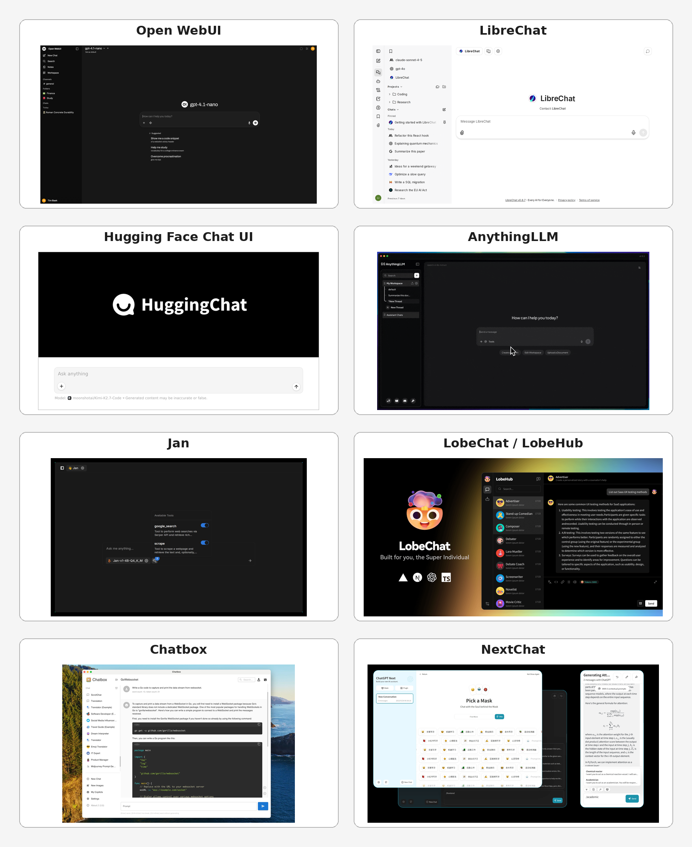
Figure 1. Side-by-side visual comparison of the eight evaluated products. Screenshots were supplied by the user; versions and capture dates were not independently verified. The LobeHub panel reflects an earlier LobeChat interface.

Detailed Assessments
The following sections explain why codebase size alone does not determine modification cost. Architecture, platform breadth, shared state, and native packaging often matter more than the raw number of source lines.

Open WebUI
Open WebUI [9] received the broadest all-around platform rating in this assessment. Its SvelteKit front end and FastAPI backend are separated clearly enough that a team can add a workspace or message visualization without first rewriting the platform. The difficulty comes from scope: conversations, models, users, groups, files, knowledge collections, tools, MCP, audio, images, Notes, permissions, and administrative functions share application state and API contracts.
A focused visual addition is practical. A new sidebar, confidence strip, evidence pane, or reasoning workspace can be implemented alongside the existing experience. Replacing the core message model is harder because it affects stores, streaming, persistence, and tool output. The Python backend is an advantage for many AI research teams, but the project is no longer a small wrapper around an OpenAI request.
Open WebUI is well suited when the prototype must inherit a mature operational platform. Its project-specific license generally requires Open WebUI branding to remain unless the deployment or distribution has 50 or fewer end users in any rolling 30-day period, written permission is obtained, or an enterprise license applies [9]. Code released at v0.6.5 and earlier remains BSD-3-Clause, and contributions merged before the branding clause retain BSD-3 rights, so a fork taken from that point carries no branding restriction. Legal review should precede a white-labeled production fork.
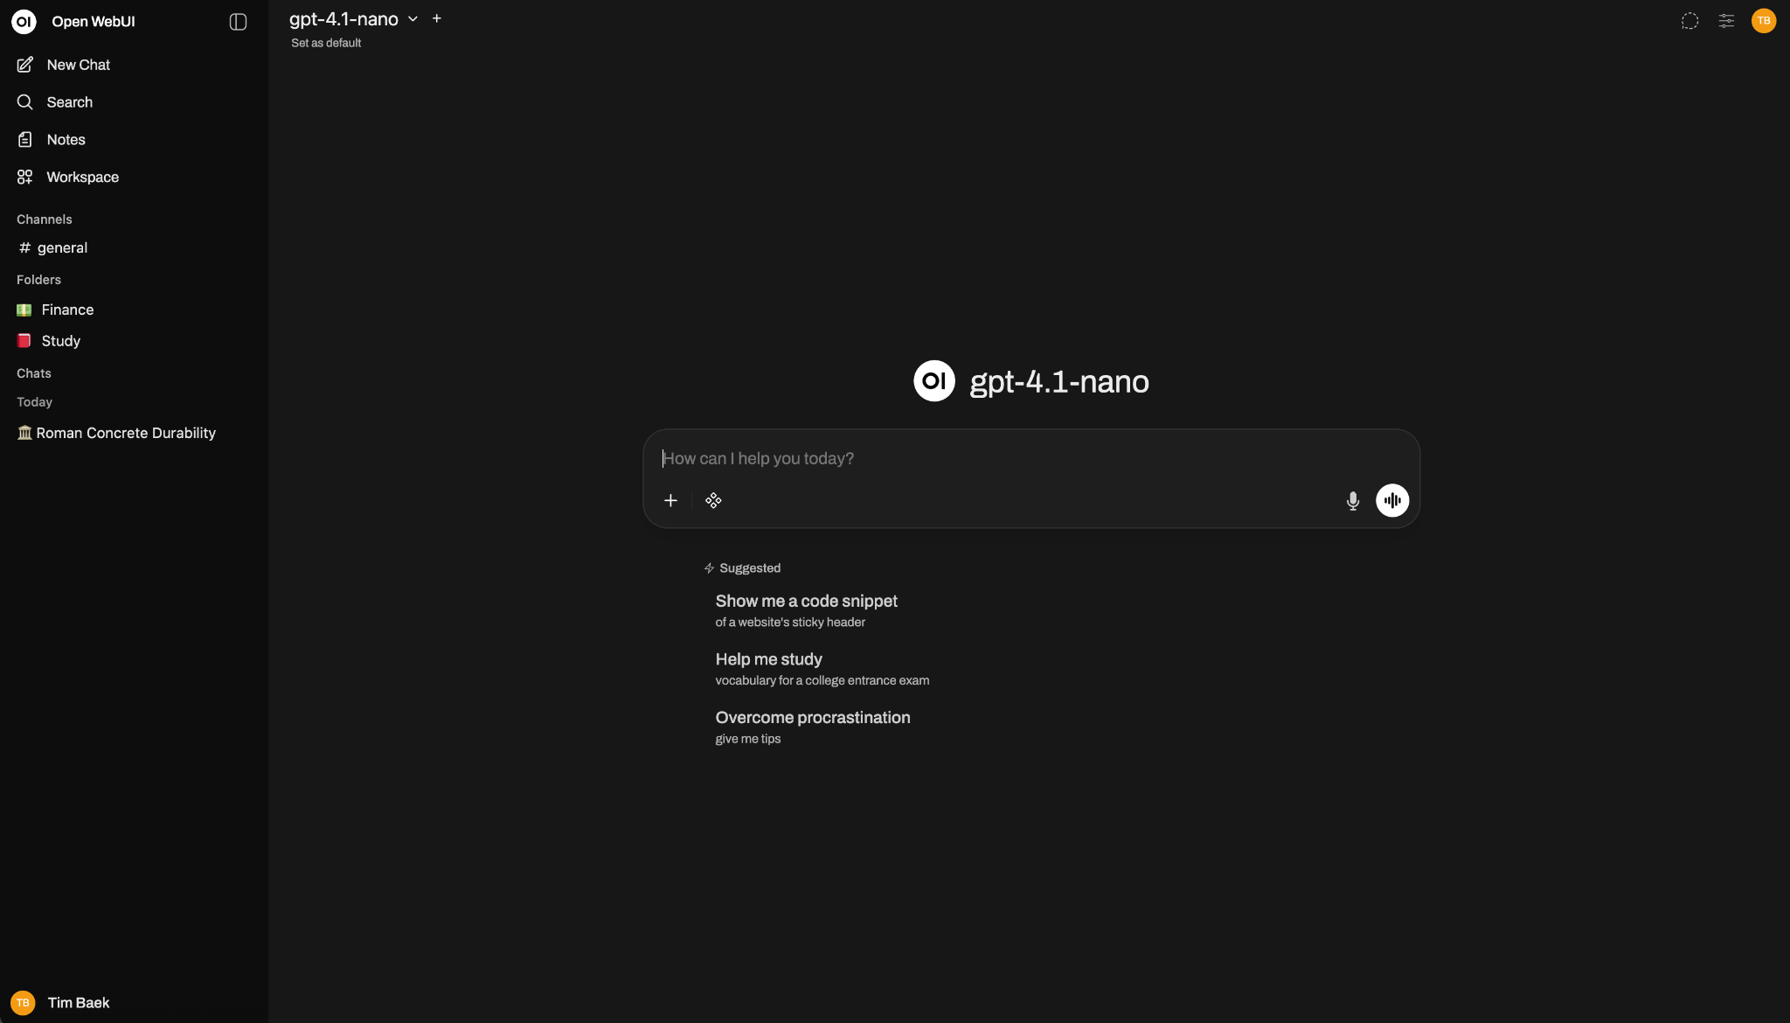
Figure 2. Representative Open WebUI interface screenshot supplied by the user; version and capture date were not independently verified.

LibreChat
LibreChat [3] received the highest capability rating among the permissively licensed full platforms in this assessment. Its documented feature set includes agents, subagents, MCP, artifacts, code execution, custom actions, web search, files, provider switching, and multi-user authentication. Code execution runs in a separate sandbox service rather than inside the MIT repository; a deployment sets LIBRECHAT_CODE_BASEURL and an API key to reach it. The project uses a monorepo with a React client, Node.js API, MongoDB schemas, and shared packages that carry types and provider behavior across the application.
That architecture supports a mature product, but it raises the assessed cost of structural changes. A change to messages, agents, artifacts, model selection, files, or streaming can cross the client, shared packages, database models, and API endpoints. Cosmetic work is manageable; changing the interaction model requires understanding several packages.
LibreChat is a strong choice when its existing capabilities are requirements. It is less efficient when the goal is to discard most of the interface and retain only the provider connection layer. Its position as the most difficult overall project in this report is an assessment result, not a maintainer or industry claim.
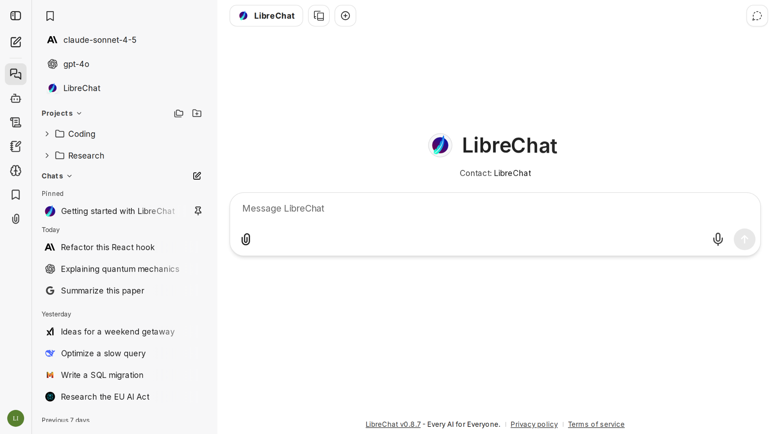
Figure 3. Representative LibreChat interface screenshot supplied by the user; version and capture date were not independently verified.

Hugging Face Chat UI
Hugging Face Chat UI [2] received the strongest balance of production capability and modifiability under this report's criteria. It is a SvelteKit application with MongoDB persistence and a focused OpenAI-compatible API boundary, and at roughly 33k measured source lines it is the second smallest project in this comparison. The current project intentionally limits provider integration to endpoints that implement the OpenAI protocol, reducing provider-specific code and making the system easier to reason about.
The interface supports responsive chat, files, history, authentication, multimodal input, model routing, and MCP tool blocks. Theming is limited to environment variables that set the application name, description, and asset folder. A developer can work in one TypeScript and SvelteKit codebase rather than crossing a separate Python or Java service. The repository remains a production application, so changes to persistence, streaming, routing, or tools require care.
This is a practical foundation when a new interface needs more infrastructure than NextChat but does not need the full administrative and RAG breadth of Open WebUI or LibreChat. The recommendation remains criteria-dependent and should be validated through a small implementation trial.
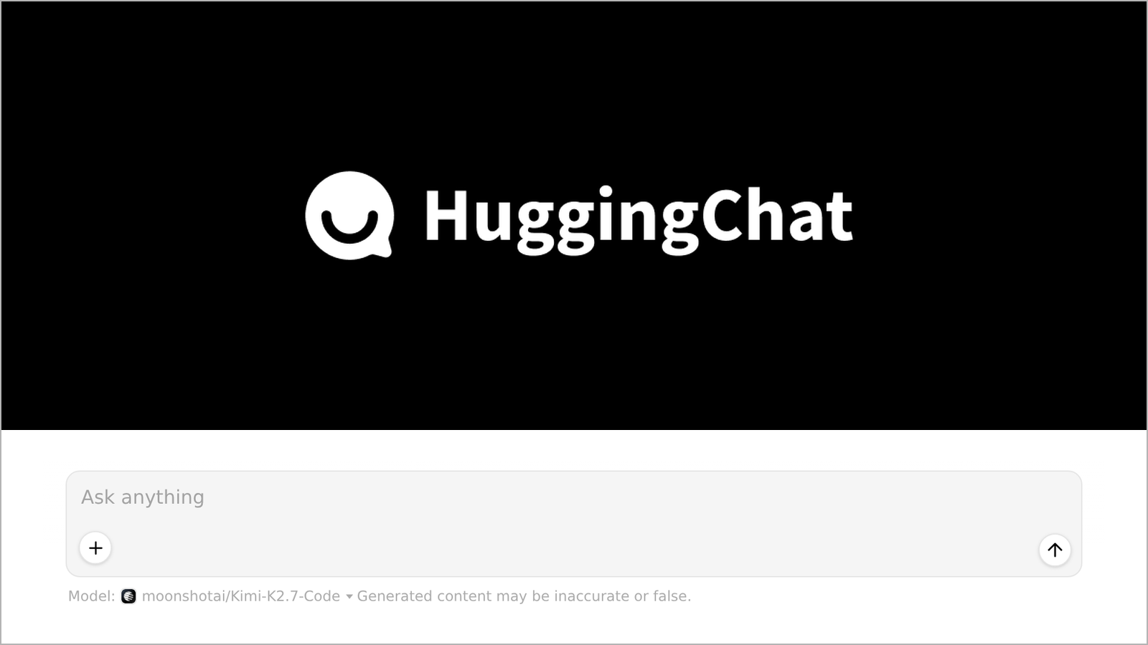
Figure 4. Representative Hugging Face Chat UI screenshot supplied by the user; version and capture date were not independently verified.

AnythingLLM
AnythingLLM [6] is oriented toward document-centered knowledge work but has expanded beyond RAG alone. It combines workspaces, ingestion, chunking, embeddings, vector databases, retrieval, citations, agents, automatic memories, scheduled AI jobs, model routing, permissions, and desktop packaging. This breadth makes it a strong candidate for private knowledge and automation workflows while also placing it among the most complex backends in the comparison.
The client is JavaScript and JSX rather than TypeScript, so a fork gains no type coverage at the component boundary. The React interface is understandable at the component level, but major changes must preserve workspace semantics, document state, agent behavior, scheduled jobs, and desktop and web execution. The server manages substantially more than model forwarding: it owns ingestion, retrieval, storage, user permissions, memory, automation, and a large integration surface.
AnythingLLM should be selected when document operations, retrieval, memory, or scheduled agent work are central requirements. It adds unnecessary weight when the product is primarily a new conversational visualization.
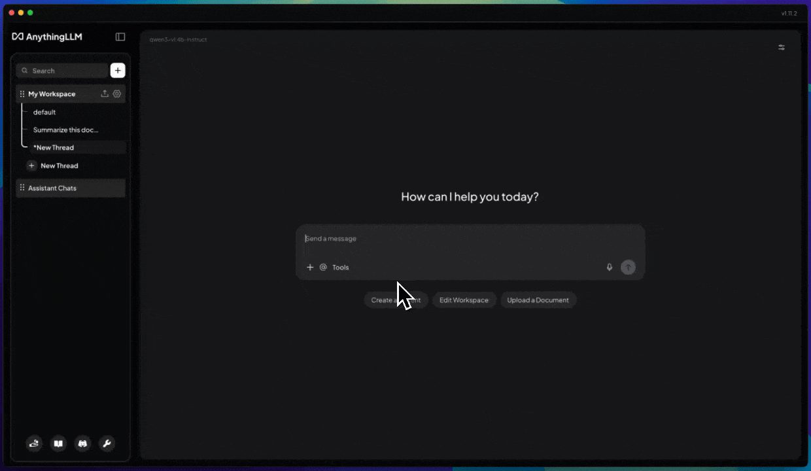
Figure 5. Representative AnythingLLM interface screenshot supplied by the user; version and capture date were not independently verified.

Jan
Jan [5] is a native, local-first desktop application. It can download and run local models, connect to cloud providers, create custom assistants, expose a local OpenAI-compatible server, and use MCP tools. The desktop product must coordinate a TypeScript interface, Tauri and Rust services, llama.cpp, native packaging, local files, and hardware-aware inference behavior.
The front end is reasonably approachable, but changes to model management or execution cross the native boundary. Back-end work can require Rust, IPC, local server behavior, and platform-specific testing. That makes Jan harder than a normal web client even when the visible interface appears compact.
Jan is well suited when local inference and native desktop behavior are requirements. It is inefficient for a browser-only interface that will call hosted OpenAI models. Its modification ranking reflects the extra TypeScript-to-Rust and native-runtime boundary rather than a claim that its visible interface is unusually complex.
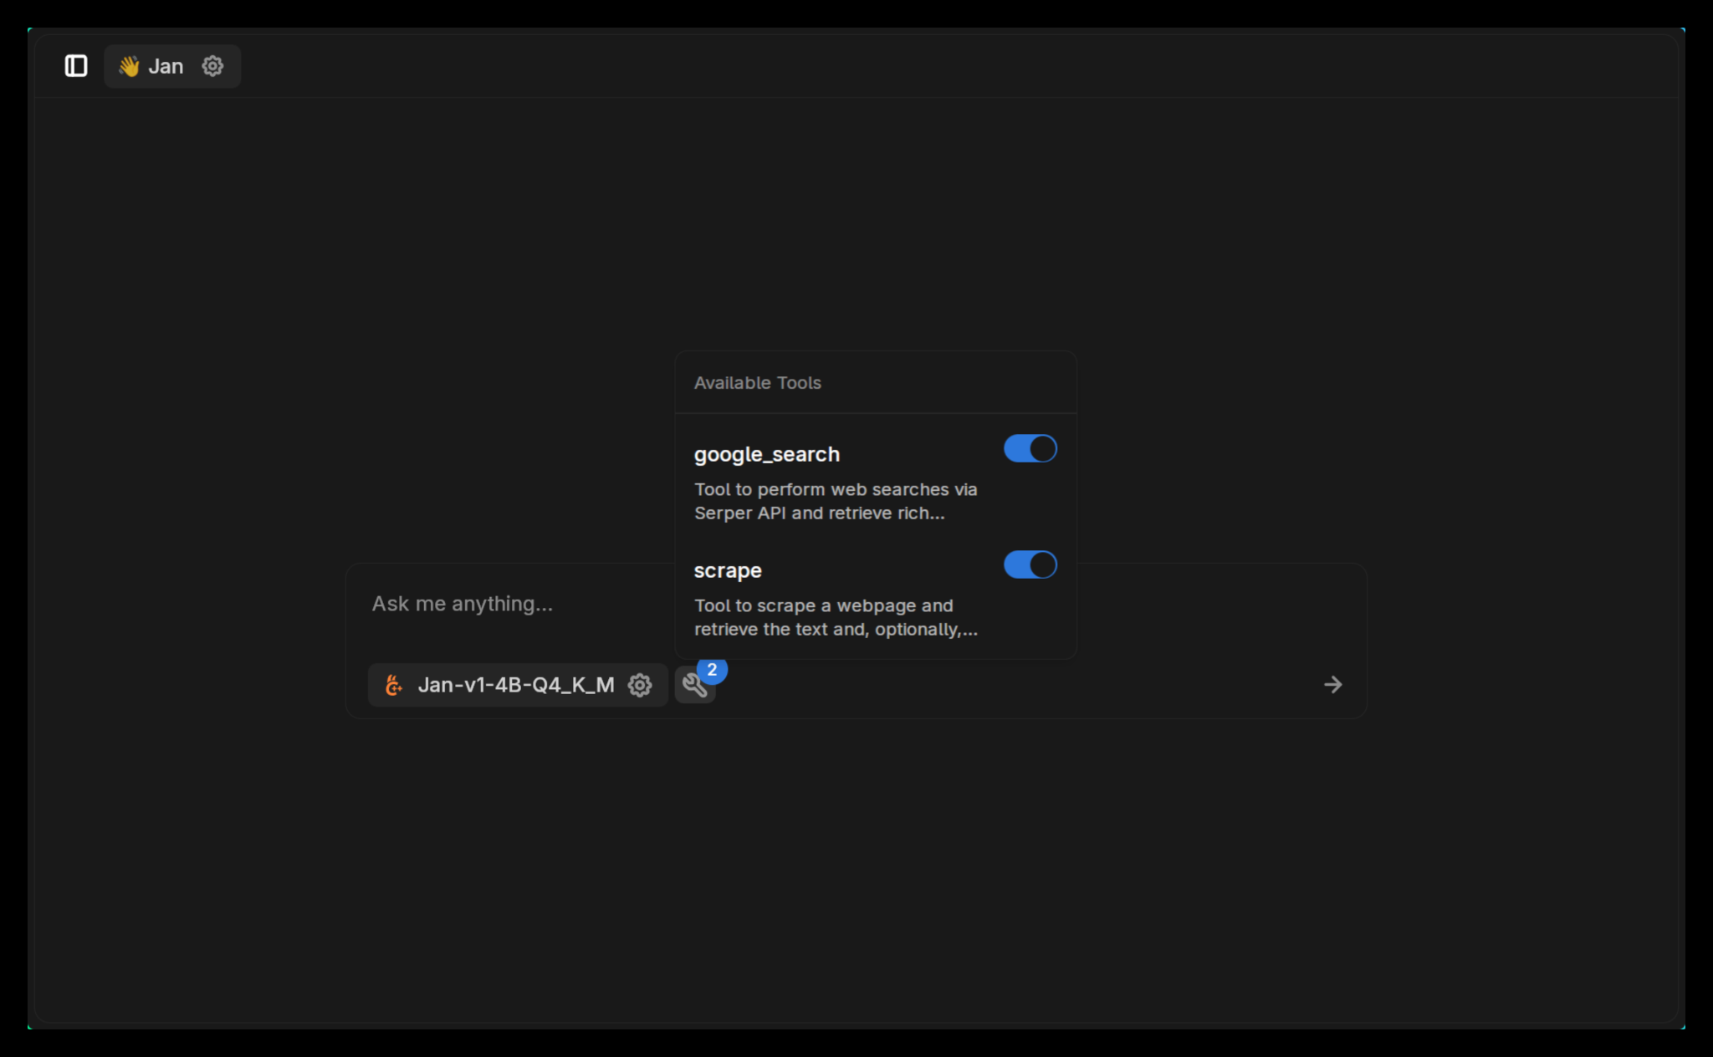
Figure 6. Representative Jan interface screenshot supplied by the user; version and capture date were not independently verified.

LobeHub (formerly LobeChat)
Current LobeHub [4] is positioned as a Chief Agent Operator rather than only a chat and assistant interface. Official project materials describe agent hiring, scheduling, task decomposition, parallel execution, reporting, heterogeneous agents, skills, MCP, knowledge, and chat. This scope makes LobeHub relevant to agent operations but less directly comparable with a focused OpenAI chat client.
The TypeScript and React stack remains familiar to web teams, but modification difficulty now includes task orchestration, agent teams, scheduling, reporting, persistence, authentication, and provider routing. At roughly 945k measured source lines excluding tests, LobeHub is the largest codebase in this comparison and about 2.5 times the size of LibreChat. That scale, combined with orchestration and scheduling, gives it the highest assessed front-end, back-end, and overall modification difficulty. The supplied screenshot is representative of that earlier interface, not the current product direction.
The license also changes the selection decision. The LobeHub Community License permits certain commercial use without source modification but requires a commercial license to develop and distribute derivative work [4]. A team planning a substantial fork should resolve that constraint before treating the project as a candidate.
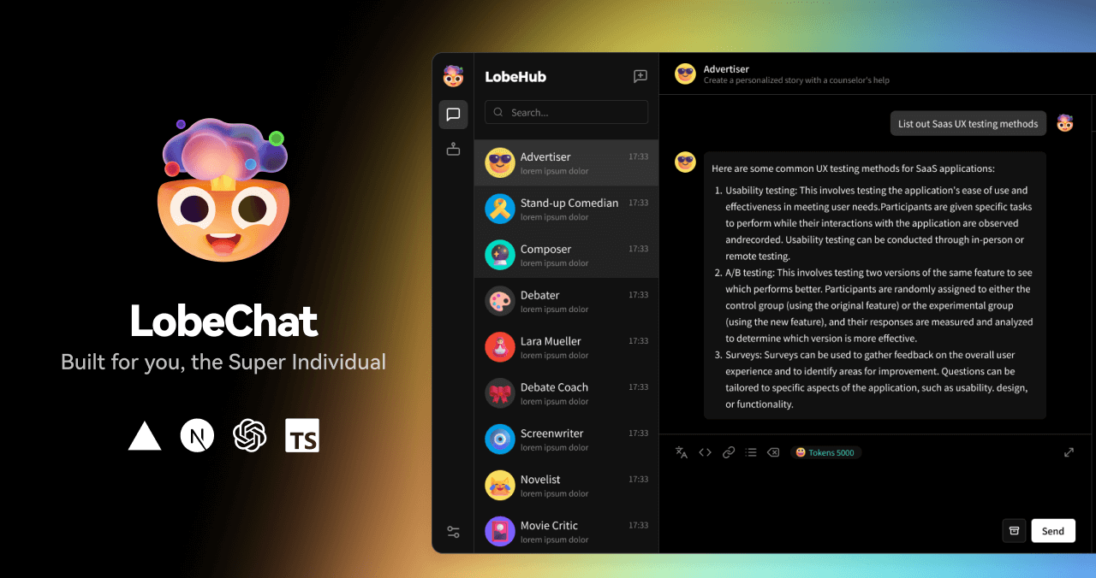
Figure 7. Representative earlier LobeChat interface screenshot supplied by the user; it does not depict current LobeHub Chief Agent Operator workflows.

Chatbox
Chatbox [1] is a cross-platform client rather than a large multi-user server. It supports multiple model providers, markdown, LaTeX, code rendering, prompt and conversation management, files, tools, search, backups, and a desktop-oriented work mode. Its smaller conceptual scope makes the conversation interface easier to modify than Open WebUI, LibreChat, or AnythingLLM. The public repository is the Community Edition, which the maintainers synchronize with a separate closed pro repository and do not recommend to most users, so a fork tracks a partial mirror rather than the full product.
The architecture still includes Electron and multi-platform packaging. Changes must account for desktop, web, and mobile behavior, local state, provider settings, and application security. The absence of a large enterprise backend reduces complexity but places more responsibility on client-side API-key handling and local persistence.
Chatbox is a practical choice for a custom personal desktop client under this assessment. It is not the strongest base for a shared research service with centralized identity, policy, and audit controls. Its relatively low modification score reflects a narrower client-oriented scope, not an industry benchmark.
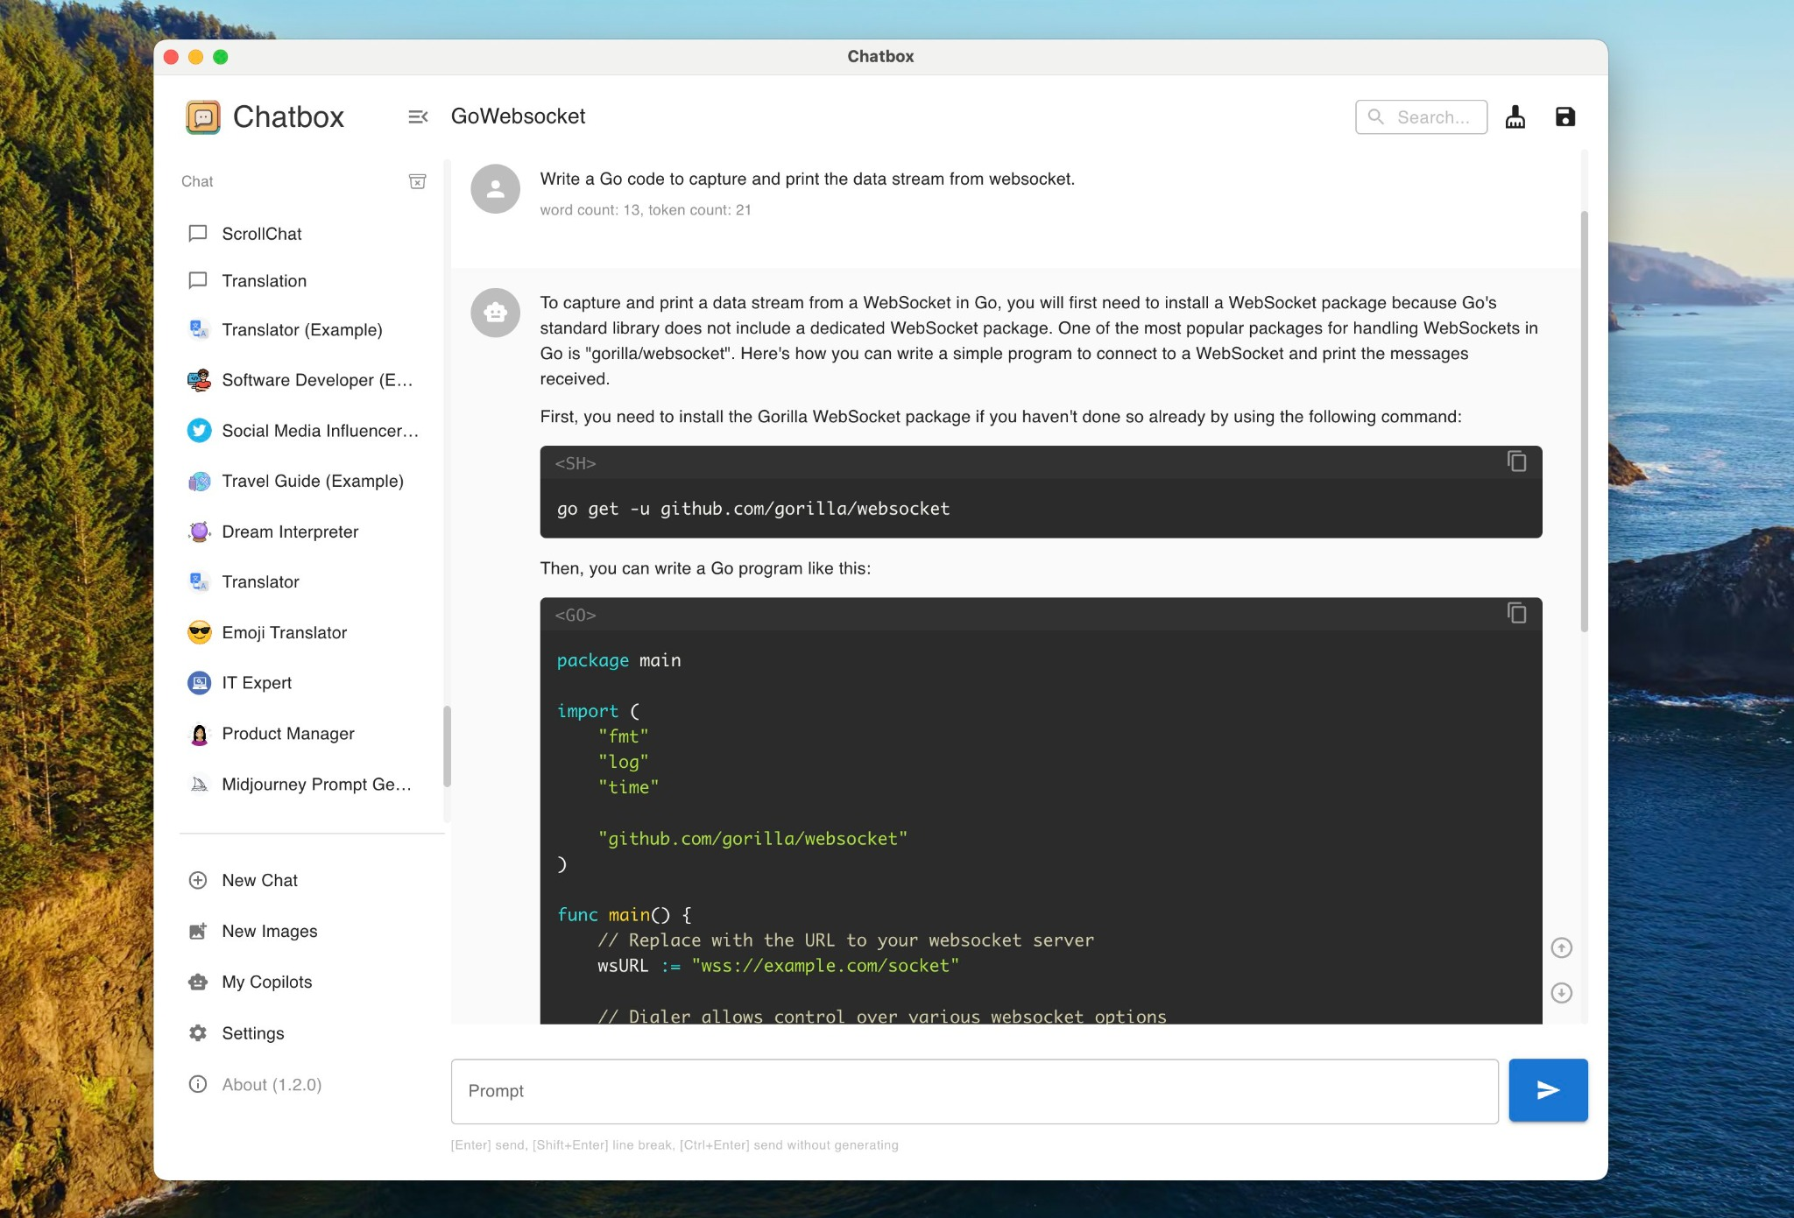
Figure 8. Representative Chatbox interface screenshot supplied by the user; version and capture date were not independently verified.

NextChat
NextChat [7] received the lowest assessed modification difficulty in this comparison. It uses a familiar Next.js and React structure, supports browser and desktop deployment, and keeps its product model close to a focused chat client. It includes responsive design, local history, prompt masks and templates, rich markdown rendering, artifacts, sharing, real-time chat, plugins, and MCP. The repository measures roughly 30k source lines, the smallest in this comparison.
A team can change navigation, message presentation, prompt composition, or the layout without first understanding a large RAG, agent, or administrative platform. The tradeoff is that many enterprise capabilities are absent or lighter. A production deployment may require new authentication, server-side persistence, governance, observability, RAG, and permission systems.
For an HCI prototype in which the interface is the contribution, NextChat is the recommended initial proof-of-concept candidate. The project minimizes inherited complexity and leaves room to build the research architecture deliberately. Release cadence qualifies the choice. The last tagged release, v2.16.1, shipped in July 2025; commit activity stopped between October 2025 and April 2026, and the July 2026 commits add unit tests and environment documentation rather than provider or model support. A team that adopts NextChat should expect to maintain its own fork. The recommendation should be confirmed by implementing representative changes rather than treating the ordinal ranking as an established fact.
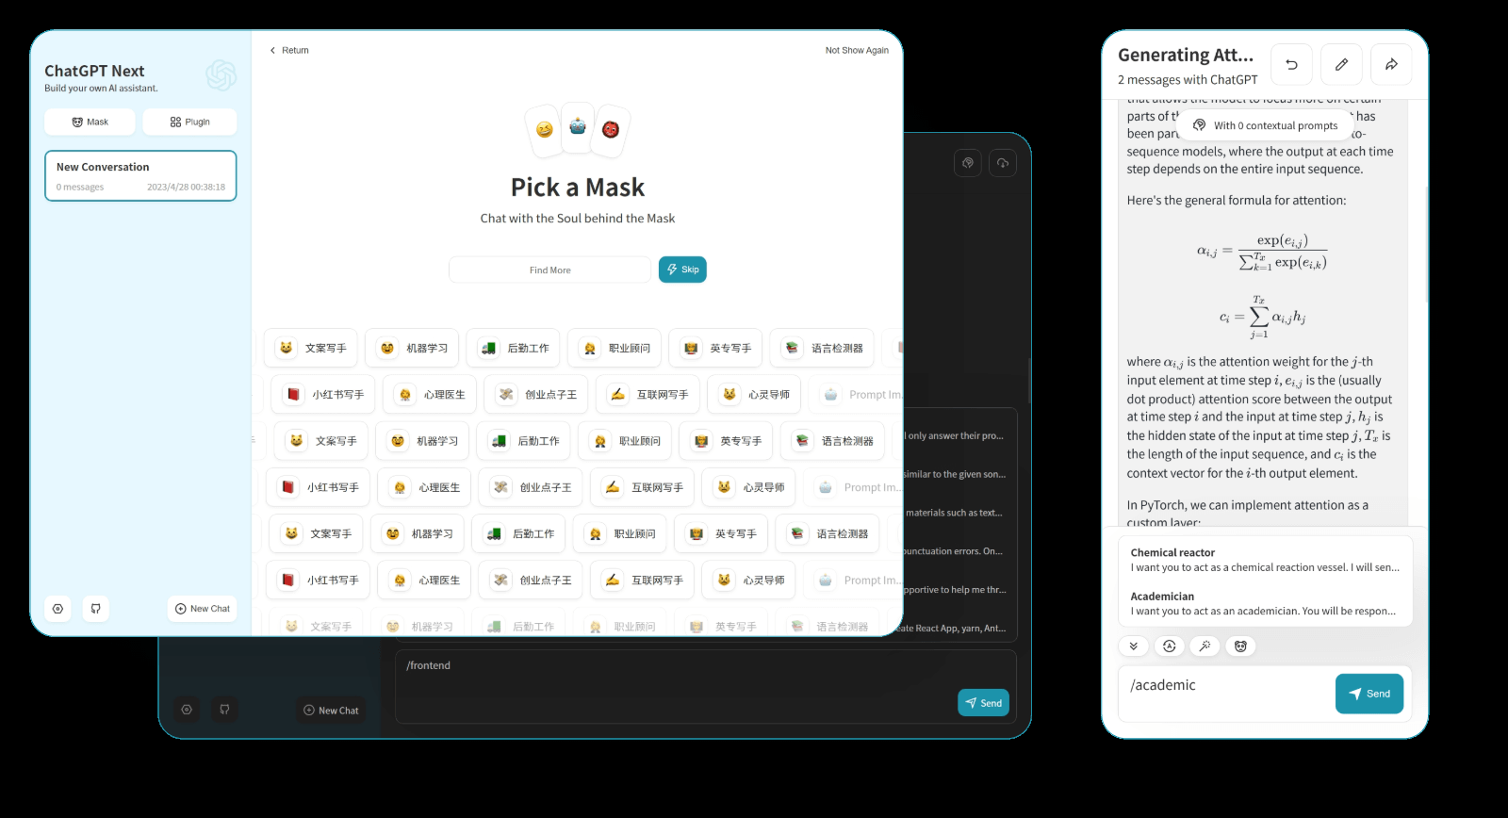
Figure 9. Representative NextChat interface screenshot supplied by the user; version and capture date were not independently verified.

Modification Difficulty Rankings
These rankings are engineering assessments derived from documented architecture, measured source scale, and repository structure. They are not published industry benchmarks and have not been validated through timed implementation tasks. A final selection should run the same small set of front-end, back-end, persistence, tool-integration, and deployment changes against the leading candidates.

Front-End Difficulty, Easiest to Hardest
1. NextChat
2. Hugging Face Chat UI
3. Chatbox
4. Jan
5. Open WebUI
6. AnythingLLM
7. LibreChat
8. LobeHub (formerly LobeChat)
NextChat received the lowest assessed front-end difficulty because it stays close to a focused Next.js and React chat application. Its navigation, message presentation, prompt composer, and workspace layout can be changed without first preserving a large RAG, agent, administrative, or multi-user platform. Hugging Face Chat UI follows because its interface and server behavior share one focused SvelteKit and TypeScript codebase of roughly 33k lines. Chatbox comes next; its client-oriented scope is narrower than the large server platforms, but at roughly 123k lines it is close to four times the size of Chat UI, and Electron, Capacitor, and multi-platform packaging add work. LobeHub anchors the hard end, with more TSX alone than the whole of LibreChat.

Back-End Difficulty, Easiest to Hardest
1. NextChat
2. Hugging Face Chat UI
3. Chatbox
4. Open WebUI
5. Jan
6. LibreChat
7. AnythingLLM
8. LobeHub (formerly LobeChat)
NextChat received the lowest assessed backend difficulty because its server side is primarily a focused Next.js API and routing layer rather than a separate enterprise platform. Hugging Face Chat UI follows because it uses a single SvelteKit and TypeScript application with a deliberately narrow OpenAI-compatible boundary. Chatbox comes next; much persistence and provider behavior remains client-side or local, although its codebase is larger. Current LobeHub anchors the hard end because task orchestration, agent scheduling, reporting, and team coordination add backend responsibilities on top of the largest server codebase in the comparison.

Overall Customization Difficulty, Easiest to Hardest
1. NextChat
2. Hugging Face Chat UI
3. Chatbox
4. Jan
5. Open WebUI
6. AnythingLLM
7. LibreChat
8. LobeHub (formerly LobeChat)
NextChat received the lowest overall customization-difficulty score because it combines the smallest measured codebase, roughly 30k source lines, with a familiar React and Next.js structure and a narrow product model. Hugging Face Chat UI ranks next at roughly 33k lines and retains a stronger production web baseline. Chatbox follows as the lowest-scored desktop-oriented alternative. LobeHub now ranks hardest overall because its measured scale exceeds LibreChat by roughly 2.5 times and its agent-operations scope adds orchestration, scheduling, and reporting. The ranking is an engineering planning aid and should be validated with a task-specific proof of concept.

Selection Guidance
A team should select the smallest codebase that already contains the difficult capabilities it cannot afford to build. The following choices follow that rule:
- Use Open WebUI when the system needs multi-user administration, RAG, tools, MCP, local models, and a Python service layer, and its project-specific branding terms are acceptable.
- Use LibreChat when the system needs broad provider support, agents, artifacts, and a permissive MIT license, and the team accepts deploying a separate sandbox service for code execution.
- Use Hugging Face Chat UI when the system needs a modern production web application but should remain understandable enough for research modification.
- Use NextChat as the first proof-of-concept candidate when the interface itself is the primary contribution and the team expects to replace navigation, message presentation, or the workspace. Plan for fork maintenance; the project has not tagged a release since July 2025.
- Use AnythingLLM when documents, retrieval, citations, memories, scheduled agents, and knowledge work are central to the product.
- Use Jan when local inference and native desktop integration are requirements.
- Use Chatbox when the target is a lightweight personal desktop client.
- Use LobeHub when agent-team orchestration, scheduling, execution, and reporting are central, and only after resolving derivative-work licensing for the intended distribution model.
For the visual reasoning work discussed in this project, the recommended proof-of-concept sequence remains NextChat, Hugging Face Chat UI, then Open WebUI. NextChat minimizes inherited structure, at the cost of maintaining the fork without upstream releases. Hugging Face Chat UI provides a stronger production baseline. Open WebUI provides the operational platform needed for a multi-user deployment. LibreChat and AnythingLLM should enter the shortlist when their existing backend features are firm requirements. Current LobeHub should be considered only if the research objective expands from chat-interface experimentation to ongoing agent-team operations.

Licensing and Open-Source Qualification
The eight projects do not carry equivalent rights. LibreChat, AnythingLLM, and NextChat use MIT licenses. Hugging Face Chat UI and Jan use Apache-2.0. Chatbox Community Edition uses GPL-3.0, which permits modification and distribution subject to copyleft obligations; that grant covers the Community Edition, which the maintainers synchronize with a separate closed Official Edition. Open WebUI uses a project-specific source-available license whose branding exception applies to deployments or distributions with 50 or fewer end users in any rolling 30-day period, unless written permission or an enterprise license applies [9]. LobeHub uses a community license that requires a commercial license to develop and distribute derivative work [4]. Open WebUI code released at v0.6.5 and earlier remains BSD-3-Clause without the branding clause.
The Open Source Definition requires free redistribution, permission to modify, and distribution of derived works under the same terms without added restrictions [8]. Neither the Open WebUI license nor the LobeHub Community License holds Open Source Initiative approval, but they diverge from the definition in different ways and a procurement process should

Conclusion
No single project is best for every goal. Under this assessment's criteria, Open WebUI received the highest general-platform capability rating, LibreChat received the highest permissively licensed full-platform rating, AnythingLLM fit document and agent-automation workflows, Jan fit native local-first use, and current LobeHub fit broader agent-team operations while introducing a material licensing constraint. These are assessment conclusions rather than industry consensus.
The engineering choice changes when modification cost becomes the primary criterion. NextChat received the lowest assessed customization difficulty, Hugging Face Chat UI ranked second and provided the strongest assessed balance for a production-quality research system, and Chatbox remained a manageable desktop alternative. LobeHub received the highest assessed difficulty once measured source scale replaced the earlier estimate. For the proposed visual chain-of-thought and human-AI collaboration interfaces, NextChat is the recommended initial proof-of-concept candidate unless multi-user administration, retrieval, and tool governance are required at the first release; in that case, Open WebUI is the stronger foundation. The final decision should be made after a reproducible implementation trial against pinned repository commits.

References
- Chatbox AI. 2026. Chatbox Community Edition. GitHub repository, README, and GPL-3.0 license. Retrieved August 3, 2026 from https://github.com/chatboxai/chatbox
- Hugging Face. 2026. Chat UI: the open source codebase powering HuggingChat. GitHub repository, README, and Apache-2.0 license. Retrieved August 3, 2026 from https://github.com/huggingface/chat-ui
- LibreChat. 2026. LibreChat. GitHub repository, README, and MIT license. Retrieved August 3, 2026 from https://github.com/danny-avila/LibreChat
- LobeHub. 2026. LobeHub: Chief Agent Operator. GitHub repository, README, and LobeHub Community License. Retrieved August 3, 2026 from https://github.com/lobehub/lobehub
- Menlo Research. 2026. Jan: a local-first AI assistant. GitHub repository, README, build notes, and Apache-2.0 license. Retrieved August 3, 2026 from https://github.com/janhq/jan
- Mintplex Labs. 2026. AnythingLLM. GitHub repository, README, releases, and MIT license. Retrieved August 3, 2026 from https://github.com/Mintplex-Labs/anything-llm
- NextChat. 2026. NextChat. GitHub repository, README, and MIT license. Retrieved August 3, 2026 from https://github.com/ChatGPTNextWeb/NextChat
- Open Source Initiative. 2007. The Open Source Definition, version 1.9. Retrieved August 3, 2026 from https://opensource.org/osd
- Open WebUI. 2026. Open WebUI. GitHub repository, README, and Open WebUI License. Retrieved August 3, 2026 from https://github.com/open-webui/open-webui

